Day 376 — Trees Revision

🔹 Task Title / Requirement
Revise the essential tree data structures and problem-solving patterns in C++: binary trees, Binary Search Trees (BSTs), traversals, height, level order, tree views, Lowest Common Ancestor (LCA), Kth smallest element, BST validation, and common interview problems.
By the end of this revision, you should be able to implement the standard algorithms, analyze their complexity, and recognize which pattern fits a tree problem.
1. Binary tree fundamentals
A tree is a hierarchical, non-linear data structure consisting of nodes connected by edges.
A binary tree is a tree in which each node has at most two children:
- left: pointer to the left child.
- right: pointer to the right child.
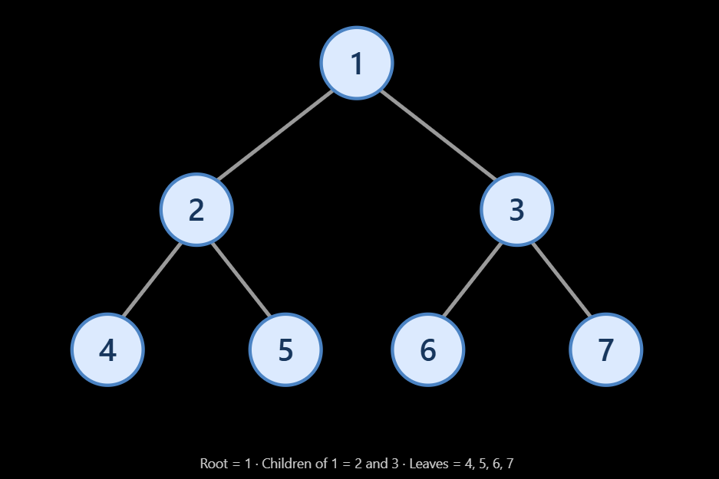

1.1 Important terminology
Term | Meaning
Root | The topmost node
Parent | A node directly above another node
Child | A node directly below another node
Sibling | Nodes sharing the same parent
Ancestor | A parent, grandparent, or other node above a given node
Descendant | A node below another node
Depth | Number of edges from the root to a node
Height of a node | Longest downward path in edges to a leaf
Subtree | A node and all its descendants
Common tree types
- Full binary tree: every node has either zero or two children.
- Complete binary tree: every level is full except possibly the last, which is filled from left to right.
- Perfect binary tree: all internal nodes have two children, and all leaves have the same depth.
- Balanced tree: height is kept approximately logarithmic in the number of nodes, according to the balance condition used.
- Skewed tree: every internal node has only one child, making the tree resemble a linked list.
1.2 Binary tree node in C++
struct TreeNode {
int val;
TreeNode* left;
TreeNode* right;

TreeNode(int value)
: val(value), left(nullptr), right(nullptr) {}
};
Each node stores its value and pointers to its children. For the examples below, assume a tree uses nullptr for missing children.
2. Binary tree traversals
Traversal means visiting each node in a particular order. The three depth-first traversals differ in when they process the root relative to its children.
Use this example tree:
1
/ \
2 3
/ \ \
4 5 6
2.1 The three depth-first traversals
Preorder — Root, Left, Right
1, 2, 4, 5, 3, 6
Visit the root before processing its subtrees.
Inorder — Left, Root, Right
4, 2, 5, 1, 3, 6
In a BST, inorder traversal produces sorted values when the BST ordering is valid.
Postorder — Left, Right, Root
4, 5, 2, 6, 3, 1
Visit the root after its subtrees; useful when deleting a tree or computing subtree results.
Recursive implementations
void preorder(TreeNode* root) {
if (root == nullptr) return;

cout << root->val << " ";
preorder(root->left);
preorder(root->right);
}

void inorder(TreeNode* root) {
if (root == nullptr) return;

inorder(root->left);
cout << root->val << " ";
inorder(root->right);
}

void postorder(TreeNode* root) {
if (root == nullptr) return;

postorder(root->left);
postorder(root->right);
cout << root->val << " ";
}
Each traversal visits every node once.
- Time: \(O(n)\)
- Auxiliary space: \(O(h)\) for the recursive call stack, where \(h\) is the tree height.
- Balanced tree: typically \(O(\log n)\) stack space.
- Skewed tree: \(O(n)\) stack space.
2.2 Level-order traversal — BFS
Level-order traversal visits nodes one level at a time, from left to right. It uses a queue.
For the example tree, the result is:
1, 2, 3, 4, 5, 6
#include <queue>
#include <vector>

vector<int> levelOrder(TreeNode* root) {
vector<int> result;

if (root == nullptr) return result;

queue<TreeNode*> q;
q.push(root);

while (!q.empty()) {
TreeNode* curr = q.front();
q.pop();

result.push_back(curr->val);

if (curr->left != nullptr) {
q.push(curr->left);
}

if (curr->right != nullptr) {
q.push(curr->right);
}
}

return result;
}
Complexity: O(n) time and O(w) auxiliary space, where \(w\) is the maximum width of the tree. The queue may hold many nodes at the same level.
Level-by-level traversal
To obtain a separate vector for each level, capture the queue size at the start of each iteration:
vector<vector<int>> levelOrderByLevel(TreeNode* root) {
vector<vector<int>> result;
if (root == nullptr) return result;

queue<TreeNode*> q;
q.push(root);

while (!q.empty()) {
int levelSize = static_cast<int>(q.size());
vector<int> level;

for (int i = 0; i < levelSize; ++i) {
TreeNode* curr = q.front();
q.pop();

level.push_back(curr->val);

if (curr->left) q.push(curr->left);
if (curr->right) q.push(curr->right);
}

result.push_back(level);
}

return result;
}
The levelSize variable ensures nodes added for the next level aren't processed in the current level.
3. Height and depth of a tree
Height measures the longest downward path from a node to a leaf. For this revision, use height in edges:
- Empty tree: height = -1.
- Leaf node: height = 0.
- A node with children: height = \(1+\max(h_{\text{left}},h_{\text{right}})\).
Some textbooks instead define height in nodes, where an empty tree has height 0 and a leaf has height 1. Either convention works if you apply it consistently.

int height(TreeNode* root) {
if (root == nullptr) return -1;

return 1 + max(
height(root->left),
height(root->right)
);
}
Include <algorithm> for max.
- Time: O(n)
- Auxiliary space: O(h)
Common interview connection: the same recursive structure is used to calculate maximum depth, minimum depth, and subtree heights. Check the required definition before changing the base case.
4. Binary Search Tree (BST)
A Binary Search Tree is a binary tree with an ordering rule. In a common unique-key BST:
- Every value in the left subtree is smaller than the node's value.
- Every value in the right subtree is greater than the node's value.
- Both subtrees must themselves satisfy the BST property.
Example:
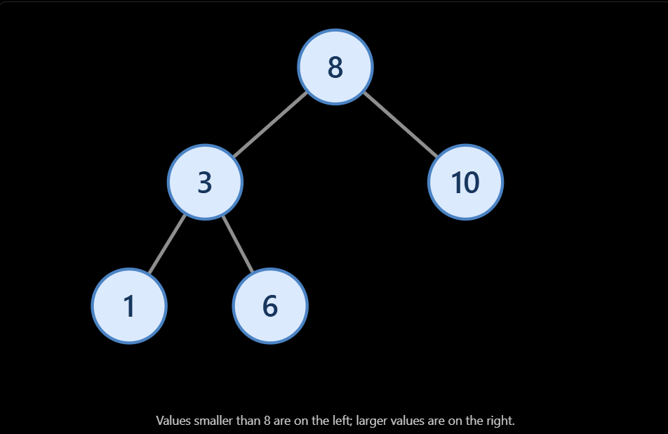
4.1 BST insertion
TreeNode* insertBST(TreeNode* root, int value) {
if (root == nullptr) {
return new TreeNode(value);
}

if (value < root->val) {
root->left = insertBST(root->left, value);
} else if (value > root->val) {
root->right = insertBST(root->right, value);
}

// Duplicate values are ignored in this implementation.
return root;
}
The key rule is to assign the recursive return value back to the child pointer. That links the inserted node into the correct subtree.
Complexity:
- Average for a reasonably balanced BST: O(log n).
- Worst case for a skewed BST: O(n).
4.2 BST search
TreeNode* searchBST(TreeNode* root, int target) {
while (root != nullptr) {
if (root->val == target) {
return root;
}

if (target < root->val) {
root = root->left;
} else {
root = root->right;
}
}

return nullptr;
}
At each step, the BST ordering lets us eliminate one subtree.
- Average: O(log n) in a balanced tree.
- Worst case: O(n).
4.3 BST deletion
Deleting a BST node has three main cases:
- Leaf node: delete it directly.
- One child: replace the node with its only child.
- Two children: replace its value with its inorder successor (the minimum value in the right subtree), then delete the successor.
TreeNode* minNode(TreeNode* root) {
while (root != nullptr && root->left != nullptr) {
root = root->left;
}

return root;
}

TreeNode* deleteBST(TreeNode* root, int key) {
if (root == nullptr) return nullptr;

if (key < root->val) {
root->left = deleteBST(root->left, key);
} else if (key > root->val) {
root->right = deleteBST(root->right, key);
} else {
// Case 1 and Case 2
if (root->left == nullptr) {
TreeNode* rightChild = root->right;
delete root;
return rightChild;
}

if (root->right == nullptr) {
TreeNode* leftChild = root->left;
delete root;
return leftChild;
}

// Case 3: two children
TreeNode* successor = minNode(root->right);
root->val = successor->val;
root->right = deleteBST(root->right, successor->val);
}

return root;
}
Call it like this:
root = deleteBST(root, key);
The root can change when the deleted node is the root itself. Failing to assign the returned pointer can leave the caller with an outdated root.
5. Validate whether a binary tree is a BST
A frequent interview trap is checking only the immediate children.
This check is insufficient:
root->left->val < root->val
root->right->val > root->val
A descendant must also satisfy every ancestor's constraint.
For example:
10
/ \
5 15
/
6
The node 6 is less than 15, but it lies in the right subtree of 10, so the entire tree is not a valid BST.
Correct solution: maintain bounds
bool isValidBST(TreeNode* root,
long long lower,
long long upper) {
if (root == nullptr) return true;

if (root->val <= lower || root->val >= upper) {
return false;
}

return isValidBST(root->left, lower, root->val) &&
isValidBST(root->right, root->val, upper);
}

bool isValidBST(TreeNode* root) {
return isValidBST(
root,
numeric_limits<long long>::lowest(),
numeric_limits<long long>::max()
);
}

Required headers: <limits>.
This implementation uses strict inequalities, so duplicate keys are rejected.
- Time: O(n)
- Auxiliary space: O(h)
An alternative is to perform inorder traversal and verify that every value is strictly greater than the previous value.
6. Kth smallest element in a BST
For a valid BST with unique keys, inorder traversal visits values in ascending order.
For example, the inorder sequence:
1, 3, 6, 8, 10
- K = 1 → answer is 1.
- K = 3 → answer is 6.
- K = 5 → answer is 10.
Iterative inorder solution
#include <stack>
#include <optional>

optional<int> kthSmallest(TreeNode* root, int k) {
if (k <= 0) return nullopt;

stack<TreeNode*> st;
TreeNode* curr = root;

while (curr != nullptr || !st.empty()) {
while (curr != nullptr) {
st.push(curr);
curr = curr->left;
}

curr = st.top();
st.pop();

--k;
if (k == 0) {
return curr->val;
}

curr = curr->right;
}

return nullopt; // k exceeds the number of nodes
}
Example usage:
auto answer = kthSmallest(root, 3);

if (answer.has_value()) {
cout << *answer << '\n';
} else {
cout << "Invalid k\n";
}
- Time: O(h + k) for a valid K, up to O(n) overall.
- Auxiliary space: O(h).
Pattern to remember: if a BST question asks for the Kth smallest or largest value, consider inorder or reverse inorder traversal, respectively.

7. Lowest Common Ancestor (LCA)
The Lowest Common Ancestor of two nodes is the lowest node in the tree that is an ancestor of both.
Consider this tree:
1
/ \
2 3
/ \
4 5
- LCA of 4 and 5 is 2.
- LCA of 4 and 3 is 1.
- LCA of 2 and 4 is 2, because a node can be an ancestor of itself.
7.1 LCA in a general binary tree
This standard recursive solution assumes both target nodes exist in the tree.
TreeNode* lowestCommonAncestor(
TreeNode* root,
TreeNode* p,
TreeNode* q
) {
if (root == nullptr || root == p || root == q) {
return root;
}

TreeNode* left = lowestCommonAncestor(root->left, p, q);
TreeNode* right = lowestCommonAncestor(root->right, p, q);

if (left != nullptr && right != nullptr) {
return root;
}
return left != nullptr ? left : right;
}
How it works:
- If the current node is null or matches either target, return it.
- Search the left and right subtrees.
- If both sides return a non-null result, the current node is the LCA.
- Otherwise, propagate the non-null result upward.
- Time: O(n)
- Auxiliary space: O(h)
If the targets are given by values rather than node pointers, first clarify how duplicate values are handled. If one or both targets may be missing, use a version that also verifies both targets were found.
7.2 LCA in a BST
The BST ordering makes this problem simpler.
- If both target values are smaller than the current node, move left.
- If both are larger, move right.
- Otherwise, the current node is where the paths split, so it is the LCA.
TreeNode* lcaBST(TreeNode* root, int p, int q) {
while (root != nullptr) {
if (p < root->val && q < root->val) {
root = root->left;
} else if (p > root->val && q > root->val) {
root = root->right;
} else {
return root;
}
}

return nullptr;
}
- Average time: O(log n) in a balanced BST.
- Worst-case time: O(n).
- Auxiliary space: O(1).
8. Tree views
A tree's view is the set of nodes visible from a particular direction. Most view problems can be solved using level-order traversal, sometimes with depth-first traversal.
8.1 Right view
The right view contains the last node at each level when viewed from the right.
For the example tree:
1
/ \
2 3
/ \ \
4 5 6
Right view: 1, 3, 6
8.2 Left view
The left view contains the first node at each level.
Left view: 1, 2, 4
One function for both views
vector<int> treeView(TreeNode* root, bool rightSide) {
vector<int> result;
if (root == nullptr) return result;

queue<TreeNode*> q;
q.push(root);

while (!q.empty()) {
int levelSize = static_cast<int>(q.size());

for (int i = 0; i < levelSize; ++i) {
TreeNode* curr = q.front();
q.pop();

if ((!rightSide && i == 0) ||
(rightSide && i == levelSize - 1)) {
result.push_back(curr->val);
}

if (curr->left) q.push(curr->left);
if (curr->right) q.push(curr->right);
}
}

return result;
}
Usage:
vector<int> left = treeView(root, false);
vector<int> right = treeView(root, true);
Time: O(n). Auxiliary space: O(w), where w is the maximum tree width.
8.3 Top view and bottom view
These views are based on horizontal distance (HD):
- Root has HD = 0.
- Left child has HD = parent HD − 1.
- Right child has HD = parent HD + 1.
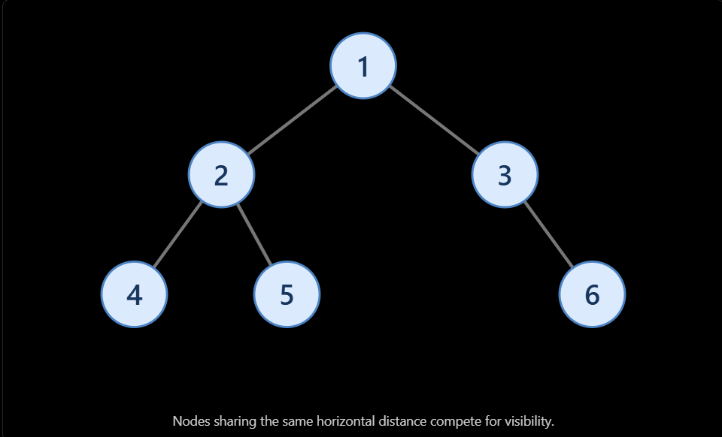
- Top view: the first node encountered at each horizontal distance when processing breadth-first.
- Bottom view: the last node encountered at each horizontal distance under a common level-order convention.
Top-view algorithm
Store (node, horizontalDistance) pairs in a queue and use a map to record only the first value at each distance.
vector<int> topView(TreeNode* root) {
vector<int> result;
if (root == nullptr) return result;

map<int, int> firstAtHD;
queue<pair<TreeNode*, int>> q;
q.push({root, 0});
while (!q.empty()) {
auto [node, hd] = q.front();
q.pop();

if (!firstAtHD.count(hd)) {
firstAtHD[hd] = node->val;
}

if (node->left) q.push({node->left, hd - 1});
if (node->right) q.push({node->right, hd + 1});
}

for (const auto& [hd, value] : firstAtHD) {
result.push_back(value);
}
return result;
}
Required headers: <map>, <queue>, <vector>, and <utility>.
Because map stores horizontal distances in sorted order, the returned values are ordered from leftmost view to rightmost view.
- Time: O(n log n)
- Auxiliary space: O(n)
For a bottom view, record the latest node at each horizontal distance instead of only the first. If multiple nodes share the same distance and depth, specify a tie-breaking rule; implementations may differ in which node they select.
9. Common tree problem patterns
Most tree interview questions can be grouped into a few reusable patterns. Recognizing the pattern often makes the solution much easier to design.
9.1 Maximum diameter of a binary tree
The diameter is the longest path between any two nodes. The path does not necessarily pass through the root.
Using height measured in edges:
\[ D=\max(D_L,D_R,h_L+h_R+2) \]
Here, \(D_L,D_R\) are the child-subtree diameters, and \(h_L,h_R\) are their heights.
int diameter(TreeNode* root) {
int best = 0;

function<int(TreeNode*)> dfs = [&](TreeNode* node) -> int {
if (node == nullptr) return -1;

int leftHeight = dfs(node->left);
int rightHeight = dfs(node->right);
best = max(best, leftHeight + rightHeight + 2);

return 1 + max(leftHeight, rightHeight);
};
dfs(root);
return best;
}
Required headers: <algorithm> and <functional>.
- Time: O(n)
- Auxiliary space: O(h)
Pattern: calculate information about the children, then update a global answer at the current node.
9.2 Check whether a tree is height-balanced
A height-balanced binary tree has left and right subtree heights differing by at most one at every node.
A straightforward approach repeatedly calculates subtree heights, which can take O(n²) time on a skewed tree. A better approach calculates height and detects imbalance in a single traversal.
int balancedHeight(TreeNode* root) {
if (root == nullptr) return 0;

int left = balancedHeight(root->left);
if (left == -1) return -1;

int right = balancedHeight(root->right);
if (right == -1) return -1;

if (abs(left - right) > 1) return -1;

return 1 + max(left, right);
}

bool isBalanced(TreeNode* root) {
return balancedHeight(root) != -1;
}
Required headers: <algorithm> and <cstdlib>.
This solution uses height measured in nodes; the balance condition is unchanged.
- Time: O(n)
- Auxiliary space: O(h)
Pattern: return a special value such as -1 to propagate failure upward and avoid repeated calculations.
9.3 Maximum depth / minimum depth
Maximum depth is the longest root-to-leaf path. Minimum depth is the shortest root-to-leaf path.
int maxDepth(TreeNode* root) {
if (root == nullptr) return 0;

return 1 + max(
maxDepth(root->left),
maxDepth(root->right)
);
}

int minDepth(TreeNode* root) {
if (root == nullptr) return 0;

if (root->left == nullptr) {
return 1 + minDepth(root->right);
}

if (root->right == nullptr) {
return 1 + minDepth(root->left);
}

return 1 + min(
minDepth(root->left),
minDepth(root->right)
);
}
Important: for minimum depth, if one child is missing, you must follow the other child. Simply taking the minimum of both child depths would incorrectly treat a missing child as the nearest leaf.
Both algorithms take O(n) time and O(h) auxiliary space.
9.4 Root-to-leaf path sum
Given a target sum, determine whether any root-to-leaf path adds up to it.
bool hasPathSum(TreeNode* root, int target) {
if (root == nullptr) return false;

if (root->left == nullptr && root->right == nullptr) {
return root->val == target;
}

int remaining = target - root->val;

return hasPathSum(root->left, remaining) ||
hasPathSum(root->right, remaining);
}
Pattern: carry the remaining target down the recursion and validate it at a leaf. An empty tree has no root-to-leaf path.
- Time: O(n)
- Auxiliary space: O(h)
9.5 Invert a binary tree
Invert the tree by swapping every node's left and right children.
TreeNode* invertTree(TreeNode* root) {
if (root == nullptr) return nullptr;
swap(root->left, root->right);
invertTree(root->left);
invertTree(root->right);
return root;
}
- Time: O(n)
- Auxiliary space: O(h)
Pattern: modify each node, then recursively process its children.
9.6 Symmetric tree
A tree is symmetric if its left and right subtrees are mirror images.
bool isMirror(TreeNode* a, TreeNode* b) {
if (a == nullptr || b == nullptr) {
return a == b;
}

return a->val == b->val &&
isMirror(a->left, b->right) &&
isMirror(a->right, b->left);
}

bool isSymmetric(TreeNode* root) {
if (root == nullptr) return true;

return isMirror(root->left, root->right);
}
Pattern: compare opposite children rather than comparing the left subtree with the left subtree.
- Time: O(n)
- Auxiliary space: O(h)
9.7 Maximum path sum — advanced pattern
For a tree containing positive or negative values, the maximum path can start and end at any nodes.
At each node:
- Calculate the maximum contribution from its left child.
- Calculate the maximum contribution from its right child.
- Update the best path passing through the current node.
- Return only one branch to the parent, because a path extending upward cannot split into both branches.
long long maxPathSum(TreeNode* root) {
if (root == nullptr) {
throw invalid_argument("Tree must not be empty");
}

long long best = numeric_limits<long long>::lowest();

function<long long(TreeNode*)> gain =
[&](TreeNode* node) -> long long {
if (node == nullptr) return 0;

long long left = max(0LL, gain(node->left));
long long right = max(0LL, gain(node->right));

best = max(best, node->val + left + right);

return node->val + max(left, right);
};

gain(root);
return best;
}
Required headers: <algorithm>, <functional>, <limits>, and <stdexcept>.
- Time: O(n)
- Auxiliary space: O(h)
Clamping child contributions to zero lets the algorithm ignore negative branches, but the global best starts at the lowest possible value so an all-negative tree still returns its largest node value.

10. Tree problem pattern recognition
If the question asks for… | Think of this pattern
Visit nodes in a specific order | DFS traversal
Process nodes level by level | BFS with a queue
Height, depth or diameter | Postorder DFS
Balanced tree | Height + early failure propagation
Validate BST | Min/max bounds or inorder
Kth smallest in BST | Inorder with a counter
Lowest common ancestor | Recursive return values; BST ordering if applicable
Left/right view | First/last node at each BFS level
Top/bottom view | Horizontal distance + map
Root-to-leaf sum | DFS with a remaining target
Invert or mirror a tree | Swap child pointers recursively
Maximum path sum | Postorder DFS + global answer
Find a value in a BST | Compare and move left or right

11. Complexity revision
Let \(n\) be the number of nodes and \(h\) the tree height.
Algorithm | Time | Auxiliary space
Preorder / inorder / postorder | O(n) | O(h)
Level order | O(n) | O(w)
Height / maximum depth | O(n) | O(h)
BST search / insertion / deletion | O(h) | O(h) recursive; iterative variants can use O(1)
Validate BST | O(n) | O(h)
Kth smallest | O(h + k), bounded by O(n) | O(h)
LCA in general binary tree | O(n) | O(h)
Diameter | O(n) | O(h)
Balanced-tree check | O(n) | O(h)
Tree views using BFS | O(n) or O(n log n) with ordered maps | O(n) worst case
For an approximately balanced BST, \(h=O(\log n)\). For a skewed tree, \(h=O(n)\). A general binary tree does not automatically have logarithmic height.

